**LipSync: User Guide**

# Introduction

The LipSync is a sip-and-puff joystick that allows a user with limited or no arm mobility to control their computer with their mouth. It emulates a computer mouse and can perform left and right clicks, scroll, and other mouse actions.

This assistive device is suitable for users with spinal cord injury, MS, ALS, and other disabilities that restrict arm movement.

# Device Compatibility

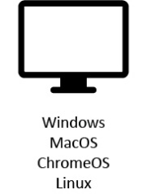

**Tablet**  
Android 4.0+  
iPadOS+  
Windows

**Phone**  
Android 4.0+  
iOS13+  
Windows

**Computer & Laptop**  
Windows  
MacOS

# Parts of the LipSync

**Wireless Status LED***Bluetooth status (LipSync Wireless only)*

**LipSync Status LED***ON / OFF, sip & puff modes*

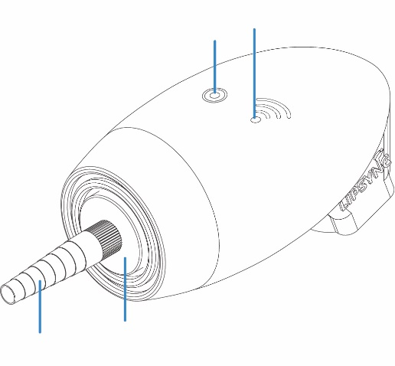

**FRONT VIEW**

**Filter***Traps saliva*

**Mouthpiece**  
*Sip-and-puff tubing*

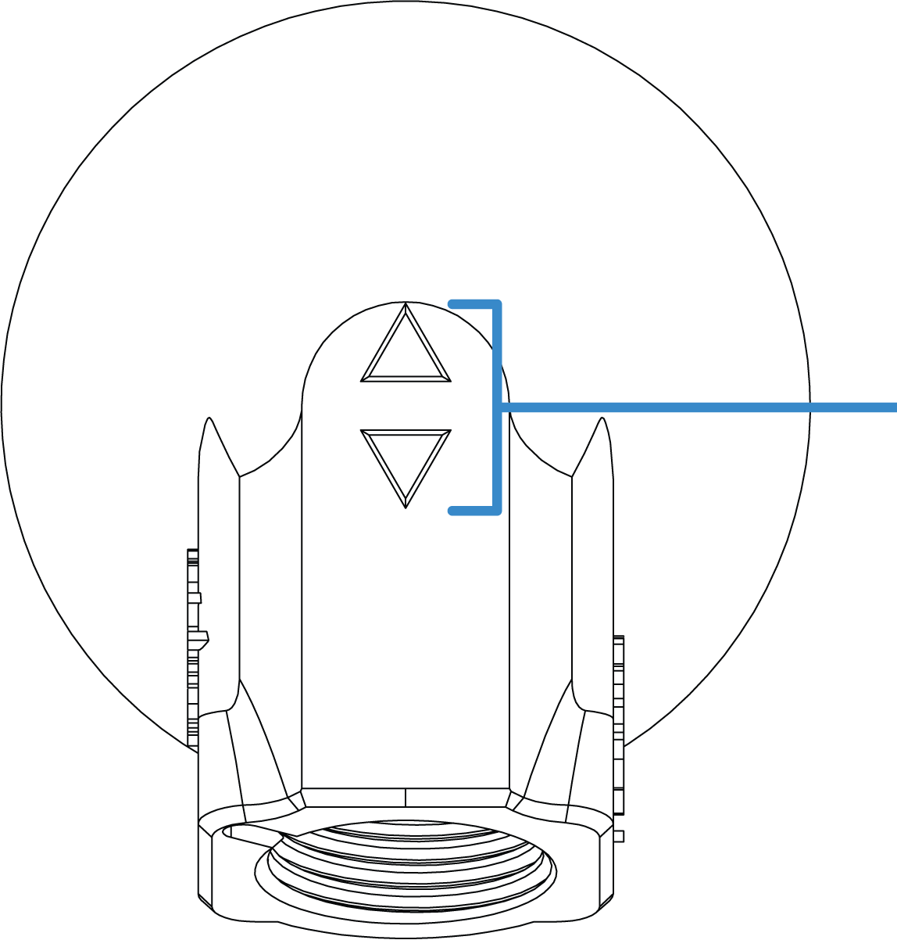

**Speed buttons**  
*Adjusts cursor speed*

**Mounting thread**  
*5/8”*

**BACK VIEW**

# Powering the LipSync

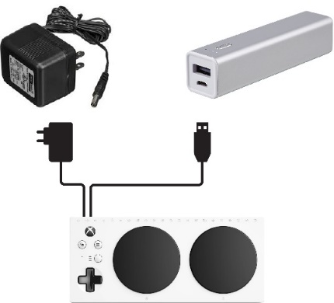The LipSync doesn’t have an internal battery so it needs to be powered at all times with an external power source. Users can draw power off of the device (except on iOS devices) or use a power bank.



or

USB  
adapter

Device

Power bank  
(>5000 mAh)

# Initialization

Allow 3 seconds for the LipSync to initialize and set the home positio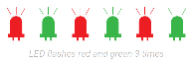n every time the LipSync is connected to power. The LipSync Status LED will flash 6 times, alternating between red and green .  
Wait until the LED stops flashing before moving the mouthpiece.

# Connecting to a Device

**For computers and Android & Windows devices** connect the LipSync USB into the device. Use an adapter if necessary.

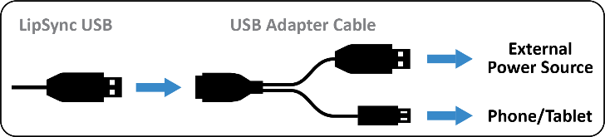

**For iOS devices** connect the LipSync USB into a USB hub. Use a USB to USB C/Lightning (depending on the device used) to connect the USB hub to your device.

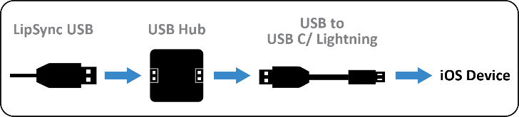

# Cursor Setup on iOS Devices

1. Open your device’s ***Settings*** > ***Accessibility*** > ***Touch*** > ***AssistiveTouch*** > Turn it on.
2. Turn off ***Always Show Menu***

# Functions for Mobile or Tablet

|  |  |  |
| --- | --- | --- |
| **FUNCTION** | **ACTION** | **ACTION TIME (SECONDS)** |
| Tap | Puff | 1 |
| Back button1 | Sip | 1 |
| Drag2 | Puff | 3 |
| Scrolling3 | Sip | 3 |
| Cursor home reset | Puff | 5 |
| Home button1 | Sip | 5 |

1 If the device uses on-screen icons, move the cursor over the icon to tap.

# Functions for Computer

|  |  |  |
| --- | --- | --- |
| **FUNCTION** | **ACTION** | **ACTION TIME (SECONDS)** |
| Left click | Puff | 1 |
| Right click | Sip | 1 |
| Double-click | Puff | 1 each |
| Drag2 | Puff | 3 |
| Scrolling3 | Sip | 3 |
| Cursor home reset | Puff | 5 |

2The red LED will stay on at all times in this mode. Deactivate by doing a 1 second sip or puff.  
3 The green LED will stay on at all times in this mode. Deactivate by doing a 1 second sip or puff.

# Cursor Speed Control



Fastest

Slowest

Default level

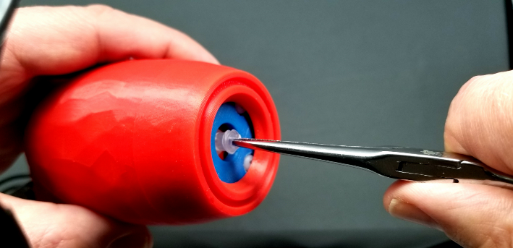

1 2 3 4 5 6 7 8 9 10 11

Press the button to increase the cursor speed.  
Press the button to decrease the cursor speed.

The LipSync Status LED will blink the cursor speed level number. The previous speed setting will be saved the next time the LipSync is used.

# Cleaning the Mouthpiece and Filter

Each user should have their own set of mouthpiece and filter for hygienic reasons. These pieces are made of acrylic plastic and have a 3–6-month life cycle. Follow these steps to clean the pieces during its life cycle:

1. 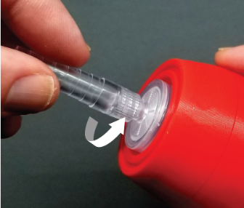With the LipSync facing you and wearing clean gloves, twist the mouthpiece and filter **counter clockwise** to remove them.

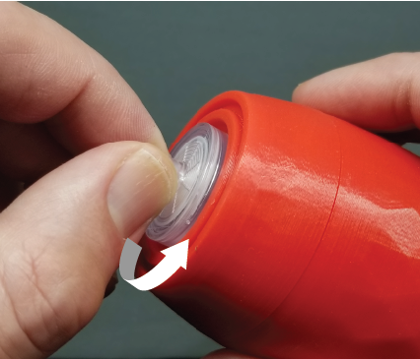

1. If the filter doesn’t twist off or the filter stem is broken, use a hemostat or extra fine tip needle nose pliers to grip and carefully twist it off. See the *LipSync: Startup Guide* for in-depth instructions.
2. **To clean the mouthpiece**: mix 1 cup (250 mL) of water with 2 tsp (10 mL) of 5% bleach (sodium hypochlorite). Soak it for 10 minutes and let it air dry or wipe with clean cloth.   
   **To clean the filter:** throw away used filters that have trapped saliva and use a clean piece.
3. Wearing clean gloves, twist the mouthpiece and filter **clockwise** **until finger tight. Do not overtighten.**

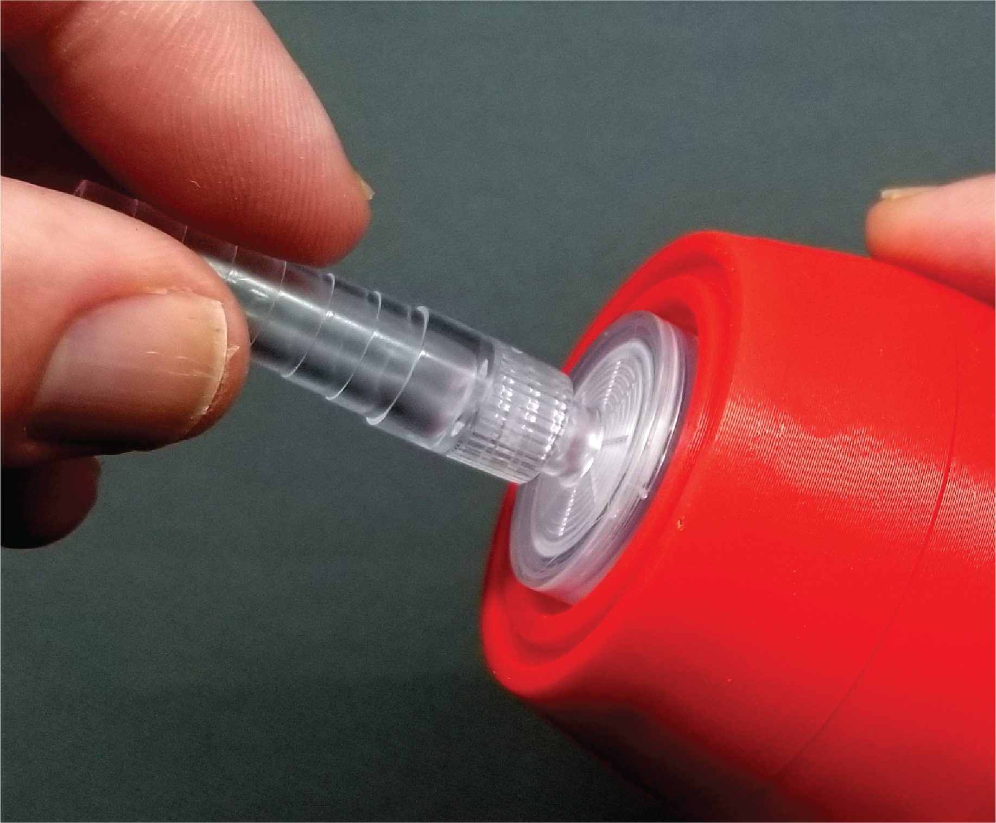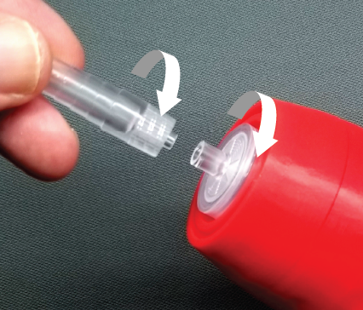

# Cleaning the LipSync Shell

* Wipe with a non-abrasive cloth lightly dampen with water or cleaning alcohol
* Don’t use abrasive cleaning materials
* Don’t soak the LipSync shell in any cleaning solutions

# Troubleshooting Cursor Issues

If users encounter drifting or inconsistent cursor movement, follow these steps in order: <http://tiny.cc/CalibrateLipSync>

1. Perform a 5 second puff for the cursor home reset.
2. Unplug the LipSync USB from the power source (e.g. power bank or device), wait a few moments before plugging it back, and let the LipSync initialize.
3. Perform joystick calibration. See the last page on the *LipSync: Startup Guide* or watch the calibration tutorial on YouTube (<https://tiny.cc/CalibrateLipSync>).

If steps 1-3 doesn’t resolve the cursor issue, contact your LipSync maker or go to the Makers Making Change Forum (https://forum.MakersMakingChange.com) for assistance.